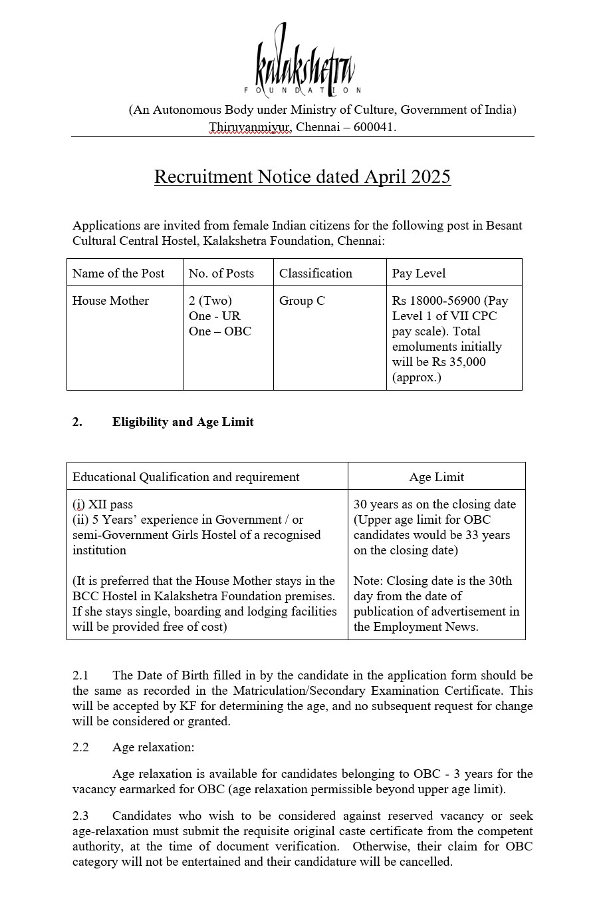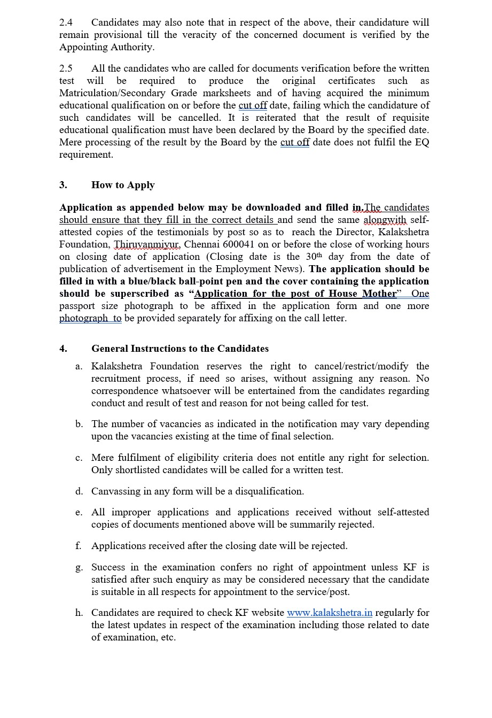

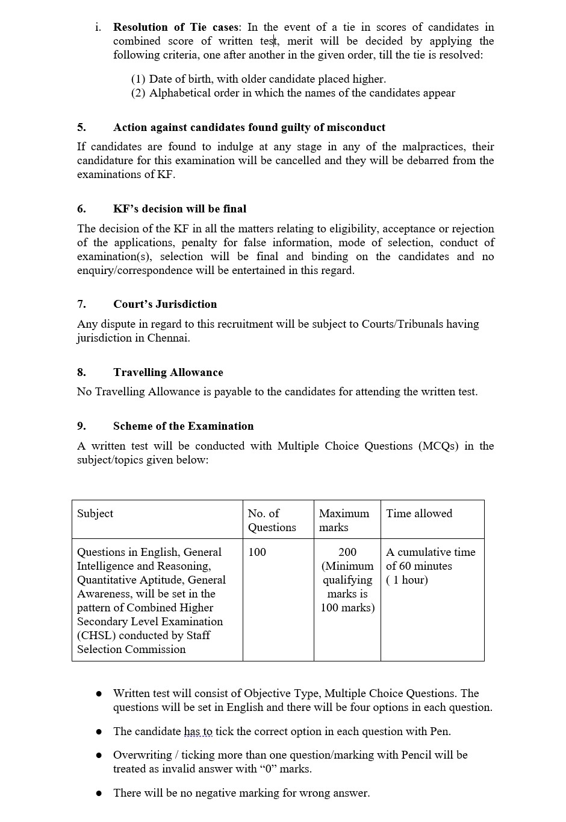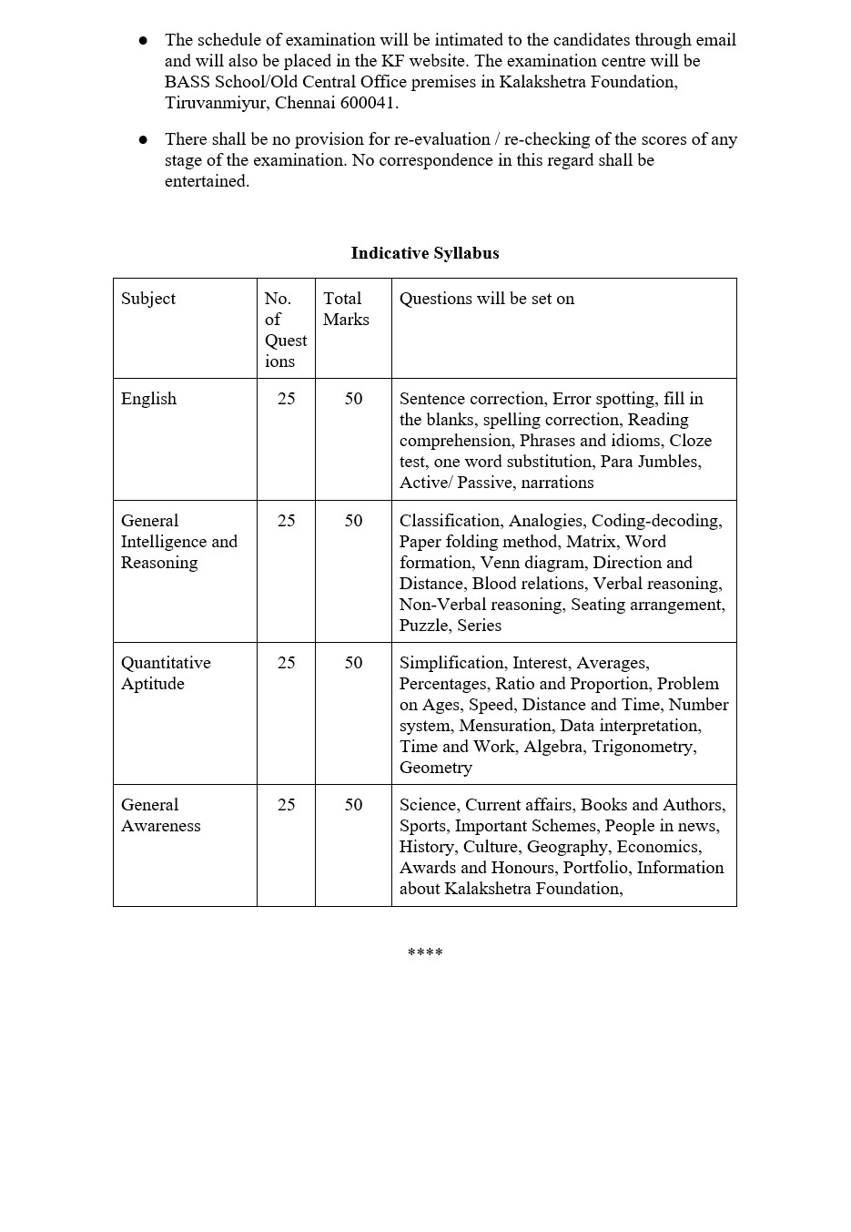

**KALAKSHETRA FOUNDATION**

Paste a recent passport size photograph

**(An Autonomous Organization under the Ministry of Culture, Govt .of India)**

**BESANT CULTURAL CENTRE HOSTEL**

**POST APPLIED FOR HOUSE MOTHER, BCC HOSTEL**

|  |  |  |  |  |  |  |  |  |  |  |  |  |  |  |  |
| --- | --- | --- | --- | --- | --- | --- | --- | --- | --- | --- | --- | --- | --- | --- | --- |
| 1. Applicant’s Name (in Block letters) | | | | | | | | |  | | | | | | |
| 2. Mother’s name | | | | | | | | |  | | | | | | |
| 3. Father’sName | | | | | | | | |  | | | | | | |
| 4. Address for communication | | | | | | | | |  | | | | | | |
| 5. i. Mobile No.  ii. Alternate Mobile No. | | | | | | | | |  | | | | | | |
| 6. Email Address | | | | | | | | |  | | | | | | |
| 7. PAN Number (optional) | | | | | | | | |  | | | | | | |
| 8. Aadhar Number | | | | | | | | |  | | | | | | |
| 9. Community :  Please indicate whether you belog to | | | | | | | | | General : OBC : | | | | | | |
|  | | | | | | | | | If belongs to OBC, please attach caste certificate from competent authority | | | | | | |
| 10. Date of Birth (DD/MM/YY)  Age as on closing date for submission of application  **Upper age limit : 30 yrs as on the closing date of application (mention age relaxation if required)** | | | | | | | | |  | | | | | | |
| 11. Nationality | | | | | | | | |  | | | | | | |
| 12. Gender:(Male / Female / Others) | | | | | | | | |  | | | | | | |
| 13. Educational qualification: | | | | | | | | | | | | | | | |
|  | S.No | Qualification | | | Board/University | | | | Year of Passing | | | Percentage/CGPA | | |  |
|  |  |  | | |  | | | |  | | |  | | |  |
| 14. Experience in Hostel Management | | | | | | | | | | | | | | | |
|  | Name of Institution | | | | | Designation | | Natureof  work | | | Period of service | | | |  |
|  |  | | | | |  | |  | | | From | | | To |  |
|  |  | | | | |  | |  | | |  | | |  |  |
|  |  | | | | |  | |  | | |  | | |  |  |
|  |  | | | | |  | |  | | |  | | |  |  |
| 15. | | | Knowledge of Indian  Languages | | | | To Read | | | To Speak | | | To Write | | |
|  | | |  | | | |  | | |  | | |  | | |
|  | | |  | | | |  | | |  | | |  | | |
|  | | |  | | | |  | | |  | | |  | | |
|  | | |  | | | |  | | |  | | |  | | |
|  | | |  | | | |  | | |  | | |  | | |
| 16. How do you consider yourself suitable for this post? | | | | | | | | | | | | | | | |
| 17.Any other information,you wish to add: | | | | | | | | | | | | | | | |
| 18. I declare that all statements made in this application are true,complete and correct to the best of my knowledge and belief. I understand that in the event of any information being found suppressed / false or in correct or ineligibility detected before or after the examination,  My candidature / appointment is liable to be cancelled and all my claims for the recruitment will stand forfeited. | | | | | | | | | | | | | | | |
|  | | | |  | | | | | | | | | | | |

|  |  |  |
| --- | --- | --- |
| Date |  |  |
| Place |  | Signature of Candidate |

Enclose a separate sheet, if the space above is insufficient.

**CHECK LIST**

|  |  |  |
| --- | --- | --- |
| **S.No.** | **Document to be submitted** | **Yes (Checkmark with solid fill ) /No ( X )** |
| 1. | Application form with recent passport size photo (Pl. Check whether all columns have been filled in and signed by the applicant) |  |
| 2. | One passport size photo (extra) in a cover |  |
| 3. | Copy of Aadhar |  |
| 4. | Proof of all educational qualifications mentioned in the Application |  |
| 5. | Proof for age |  |
| 6. | Testimonials for Hostel experience |  |
| 7. | Other relevant certificates/testimonials regarding qualification, if any |  |