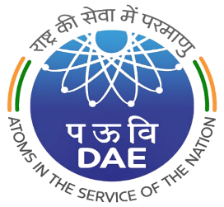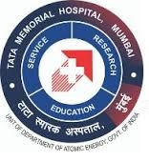
TATA MEMORIAL CENTRE
TATA MEMORIAL HOSPITAL
PAREL, MUMBAI – 400 012

(A GRANT-IN-AID INSTITUTE UNDER DEPARTMENT OF ATOMIC ENERGY, GOVT. OF INDIA)

TMC/ACAD/87/2025 02.07.2025

WALK-IN-INTERVIEW on 21.07.2025 for 01 YEAR TMC FELLOWSHIP & SENIOR RESIDENT (PROTON THERAPY) IN THE DEPARTMENT OF RADIATION ONCOLOGY

Reporting Time & Venue: 09:00 A.M. to 09:30 A.M. at Homi Bhabha Block, 13th Floor, Training Cell, Tata Memorial Hospital, Parel, Mumbai

Sr.  No. | DESCRIPTION | ESSENTIAL QUALIFICATIONS
1 | SENIOR RESIDENT  (PROTON THERAPY) | MD / DNB in Radiation Oncology OR equivalent PG degree with 01 year of experience.
2 | NEURO RADIATION ONCOLOGY FELLOWSHIP
3 | THORACIC RADIATION ONCOLOGY FELLOWSHIP

CONSOLIDATED REMUNERATION : Rs. 1,27,260/- p.m. (Gross Pay)

AGE LIMIT: 40 YEARS. (Relaxable by 5 years for SC/ST, 3 years for OBC & 10 years for Physically Handicapped).

Eligible and Interested candidates may attend walk-in-interview. Please bring Resume, recent passport size photograph with attested copies of all qualification & experience certificates. [Any doubts regarding the post may be clarified by emailing to: tmhresident@tmc.gov.in.]

( S.D. BANAVALI)
DIRECTOR (ACADEMICS), TMC

